Charlie Geisler
Professor Clayton
CYB-3900-001
OSINT Activity #2
10 October, 2025

1. When will the new iPhone be released? How many versions will there be? What
new features will be included?
The new iPhone should be released in September 2026 (See Appendix 1A). There will be 3-4 versions, with new features such as doing away with FaceID and making a folding phone. This can be explained by the history of Apple releases where they usually have had multiple versions. Each one has been released in September in the past (Appendix 1B/1C). Based on what Apple has done in the past with these releases, I am 80% confident in the answers. I am only 80% confident because I cannot guarantee knowledge of the numbers of iPhones because these vary. The tool I used was Wayback machine and verified that past releases happened in either early or late September.
2. What is the biggest cybersecurity firm in Colorado? Who are their direct
competitors? How secure are they in their position as the biggest firm?
Datadog is listed as the “Top” cybersecurity firm in Denver. From builtincolorado.com, their direct competitors appear to be Red Canary and EPAM Systems. I was unable to find how secure they are in their position. Another point why they are a top business is their CEO was named a “Top Consulting Firm CEO of 2024” (Appendix 2).
3. Which website uses the IP Address 54.239.28.85? What is the IP Address for
MSU Denver’s Homepage? The MSU Denver Student Hub?
The answer to the first IP address is US Ashburn Amazon Technologies (Appendix 3A).
Secondly, MSU Denver’s homepage is 141.193.213.20. MSU Student Hub is the same as it is hosted on the same server. Found this using WhoIS tool domain lookup. (3B) I am 99% sure about this result because it is rare for the ip lookup to return an inaccurate domain.
4. Which Colorado universities/colleges are MSU Denver’s biggest competitors in
the criminal justice field? What are the biggest differences between the programs?
Main competitors are Colorado Christian University and CU Denver. The biggest differences are that CCU puts moral and ethical aspects of justice in their academic program while CU Denver combines this with scientific applications. The tools I used to figure this out was Google advanced search with the specific query “MSU Denver” Criminal Justice “Competitors”. My confidence in this result is low, because I experienced difficulty in knowing which features of the program were important enough to be a “competitor” with the MSU program I am researching.
5. What are Auraria Campus’s property lines (i.e. what are the legal boundaries)?
A picture is provided in the appendix (5) of the property lines information. I found that the property lines fall between Water Street and Interstate 25, along Auraria Parkway (between Speer Boulevard and 9th Street), and along Speer Boulevard (between Auraria Parkway and approximately Chopper Circle/Wewatta Street) (Appendix 5A). I used a Google advanced search query to locate “property lines.” Since this information was republished February 25, 2025, I am highly confident in the accuracy. The pdf is the Denver zoning code used by the city’s planning and development department, so it is the most accurate reference of information defining zone districts.

6. How many colleges and universities have a physical location in Denver, CO (not
including the surrounding areas/suburbs)?
There are 20 colleges and universities physically in the Denver area not including suburbs. The tool I utilized for verifying this is the National Center for Education Statistics. The website has a filtering tool in which I entered 802xx as the zip code, as this is the zip code for Denver excluding suburbs. I also changed the filter to include only “colleges.” (Appendix 6). The NCES is the source of definitive college information so I can be highly confident in this number.
7. Find a conspiracy theory that turned out to be true. Why was it considered a
conspiracy in the first place?
Operation Northwoods – this was in 1962 when the Secretary of Defense was told to stage terrorism in US cities/assets and falsely blame these on the Cuban regime under Fidel Castro. It was considered a conspiracy because it was compartmentalized like much of the operations within Defense. I used the search query “Northwoods” because I had previous knowledge of this and knew there would be a declassified document I can provide. Attached link shows the proposal for the operation and its constraints (Appendix 7). Since it is an official document of the U.S. government, one can be quite certain in this evidence.
8. What is the biggest intelligence/national security failure or scandal in the past 15s
years that didn’t make national headlines? Why don’t more people know about it?
Biggest national security failure was the NSA violated the privacy of American citizens’ data. The tool I used was a Google search <FISCR “Failure”> and found the document from congress for the court’s October 18th ruling on the subject. (Appendix 8) It is likely that this did not make headlines is likely because it is technically dense so difficult to understand for the public. I can be highly confident in this result because of the official congress document from the October 18th ruling.
9. How does the overall crime rate in Colorado compare with other states? What
about the murder rate specifically? Sexual assault? Carjackings?
I figured the best source for this information would be the FBI’s National Incident-Based Reporting System, where I found that Colorado’s violent crime rate is near the national average, whereas property crime is significantly above. Property crime mostly involves motor vehicle theft. The murder rate is below the national average. Sexual assault is higher than average. I can be highly confident because the use of the filters narrows it down and virtually all crimes are kept track of using this service.

10. What are the biggest crime hotspots in Denver, CO? Which crimes are most
prominent there? How often are they patrolled by DPD in relation to other areas?
Using the DPD interactive crime map (Appendix 10) I could find that theft and motor vehicle theft are the most prominent crimes there. The Central Business District receives the highest volume of officers so this appears to be the crime hotspot. I found this out using the patrol frequency feature within the filters. I found this using the keyword “Denver DPD crime map”. I am highly confident in this because patrol density is a well-established means of allocation of crime.

Appendix
1A.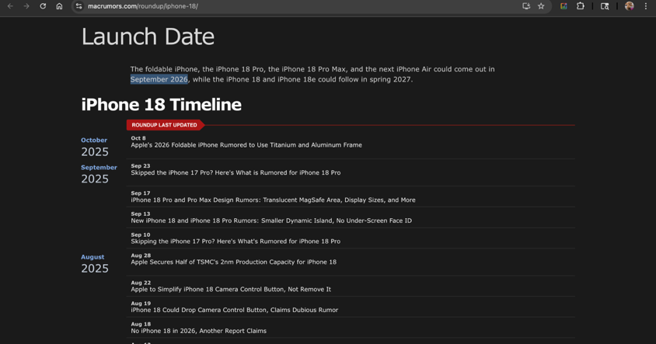
Screenshot 10/10/2025 at 4:26:22 PM UTC (macrumors.com/roundup/iPhone-18)
1B.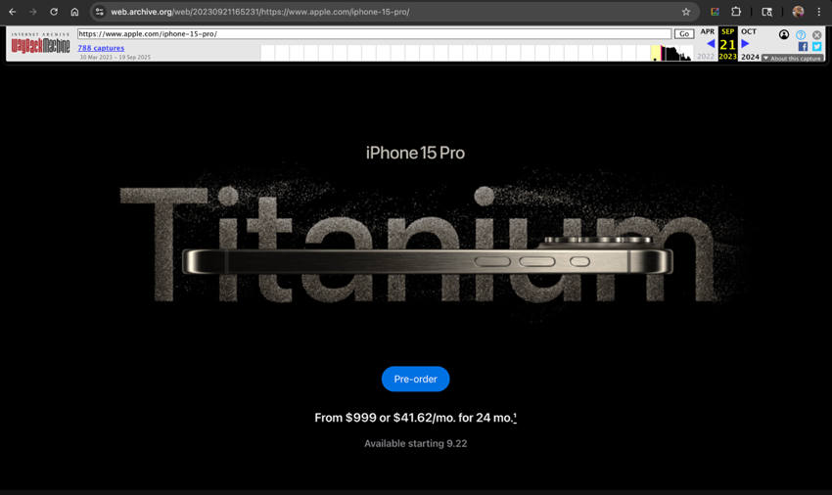
Screenshot 10/10/2025 at 4:34:10 PM UTC (web.archive.org/web/http://20230921165231/iphone-15-pro)
1C. https://infonewt.com/apple-release-patterns
2. https://www.prnewswire.com/news-releases/optiv-ceo-kevin-lynch-named-a-top-consulting-firm-ceo-of-2024-302356548.html
3. 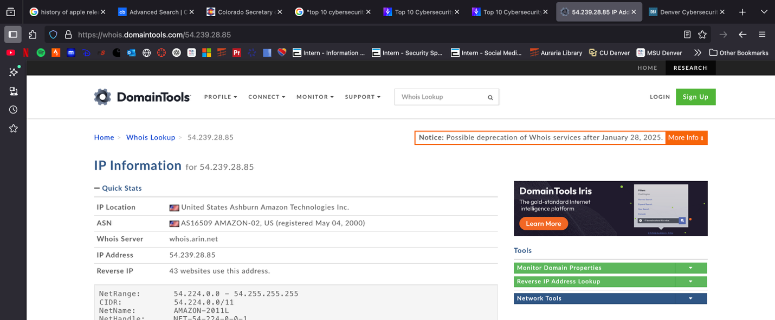
Screenshot 10/10/2025 at 5:26:20 PM UTC (https://whois.domaintools.com/54.239.28.85)
3B: https://whois.domaintools.com/msudenver.edu
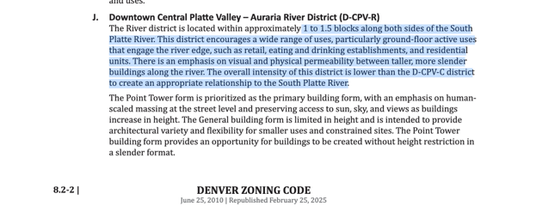
5A. *Images below retrieved from this link (Screenshots 2025-10-14 at 7.37-7.42 PM UTC)
https://denvergov.org/files/assets/public/v/1/finance/documents/assessor/2025/2023-vs-2025-sfr-and-rh-value-change.pdf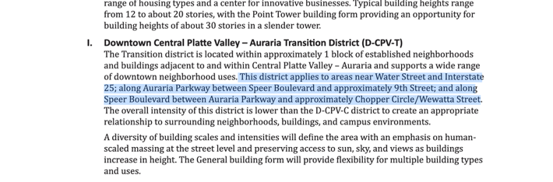
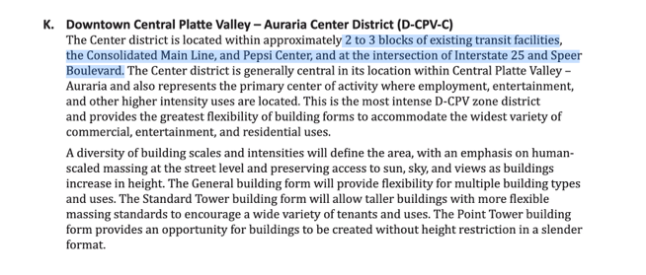
6. 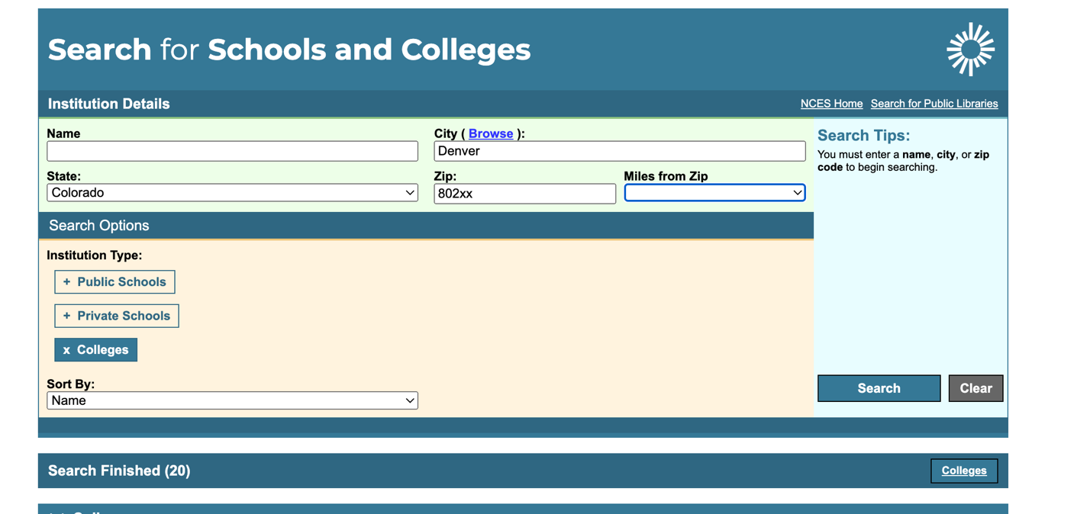Screenshot 2025-10-14 at 8.18.26 PM
Link to search query: https://nces.ed.gov/globallocator/index.asp?search=1&itemname=&city=Denver&State=CO&zipcode=802xx&miles=1&College=1&sortby=name&CS=8C34BFED

7. https://catalog.archives.gov/id/305036
8. https://www.congress.gov/115/plaws/publ254/PLAW-115publ254.pdf?inline=1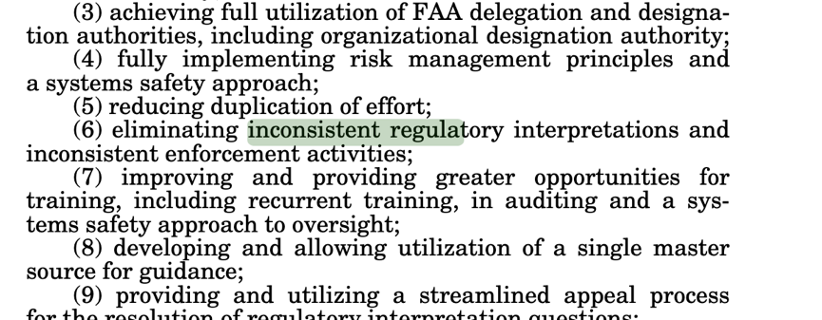p.68
Screenshot 2025-10-14 at 8.33.51 PM UTC
9. 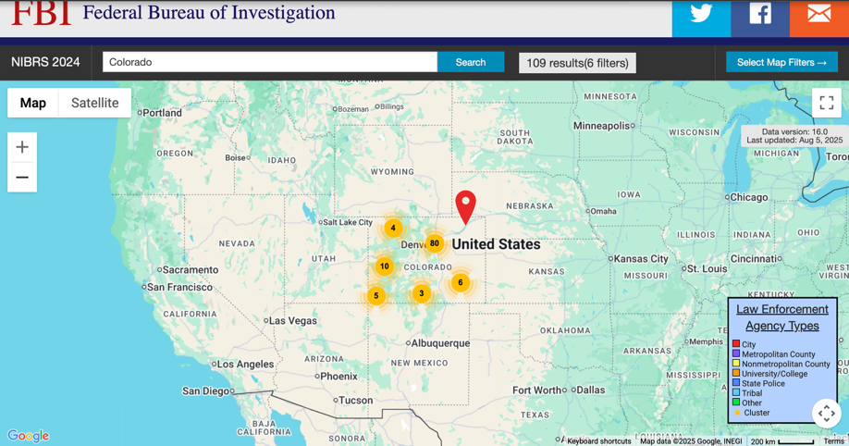
Screenshot 2025-10-14 at 8.39.52 PM UTC
https://nibrs.fbi.gov/2024/
10.
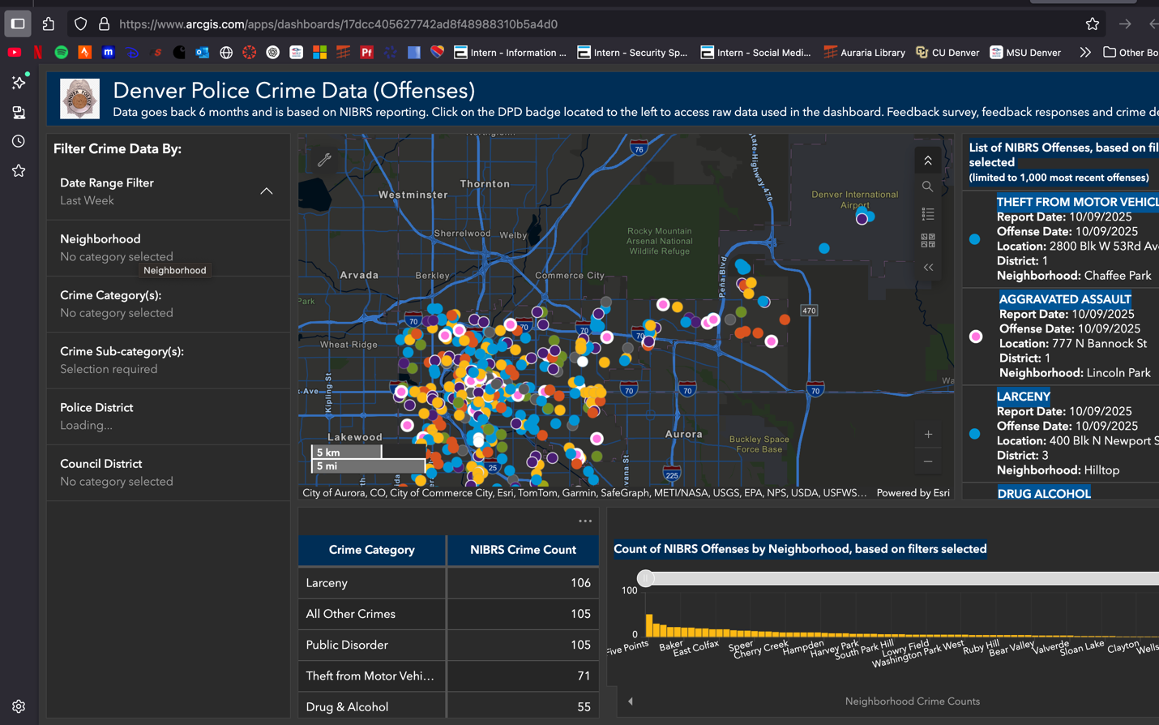
https://www.arcgis.com/apps/dashboards/17dcc405627742ad8f48988310b5a4d0

